**VIDEO VIOLENCE DETECTION**

**USER GUIDE**

**Step 1: Download Project Files**:

* Download the project files provided in the compressed folder named "VideoViolenceDetection".

**Step 2: Extract Project Files**:

* Extract the contents of the "VideoViolenceDetection" folder to a location of your choice on your computer.

**Step 3: Install Python**:

* If Python is not already installed on your system, download and install Python from the official website: [https://www.python.org](https://www.python.org/).
* Follow the installation instructions provided on the website for your specific operating system.

**Step 4: Install Required Dependencies**:

* Open a command line interface (e.g., Command Prompt on Windows, Terminal on macOS/Linux).
* Navigate to the directory where the project files are extracted.
* Run the following command to install the required Python dependencies:

**pip install -r requirements.txt**

*(or)*

* Install the following packages
* pip install Flask # For creating web applications in Python
* pip install numpy # For numerical computations
* pip install opencv-python # For image and video processing
* pip install keras # For deep learning models
* pip install tensorflow

**Step 5: Modify path:**

* Modify the path of the model in the code according to the user path

**Step 6: Run the Project**:

* In the command line interface, navigate to the directory where the project files are extracted.
* Run the main Python file to start the Flask server. Use the following command:

**python app.py**

* Once the server is running, you will see a message indicating that the server is running locally.
* Open a web browser and enter the following URL to access the project:

[**http://localhost:5000**](http://localhost:5000)

The project's user interface should now be accessible in your web browser.

**Step 6: Project Usage**:

* Upon accessing the project in your web browser, you will be able to upload video files for analysis.
* Follow the on-screen instructions to upload a video file and initiate the violence detection process.
* The system will analyze the video in real-time and provide alerts when instances of violence are detected.

**OUTPUT**

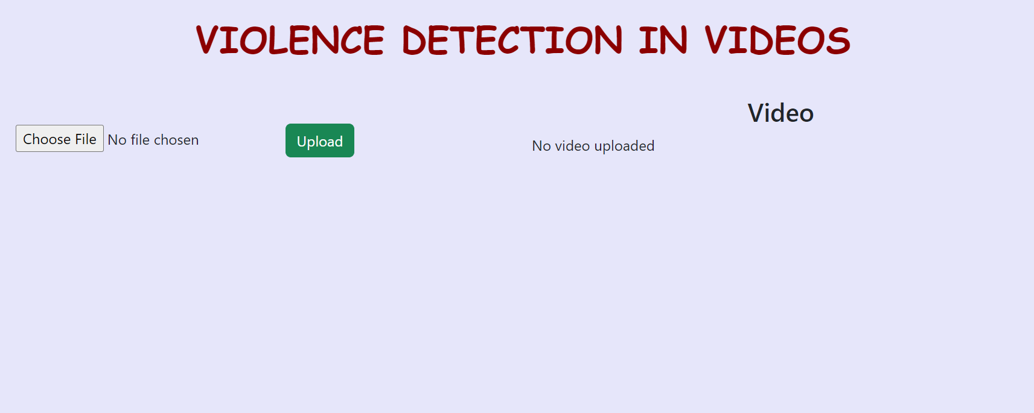

* After Processing the video the browser will display the violence detected at the timestamps in the video

